Sashin Tulsiram

sashintulsiram@gmail.com

sashin tulsiram – full stack developer challenge

ReadMe

Table of Contents

Introduction 2

Application Prerequisites 2

Set Up MySQL Server 2

Set up MySQL Workbench and import database 4

Install NodeJS 20.5.1 9

Install Python 3.11.x 9

Clone the GitHub repository 10

Create a virtual environment 10

Test Web Application 11

Start Web Application 11

Illustration of Web Application 12

Contact Information 16

# Introduction

This project was developed according to the Full Stack Development Challenge - it was developed using Python, MySQL, React and a custom developed REST API using Python. Please note that this ReadMe was compiled and tested on a Windows 11 Operating System.

# Application Prerequisites

## Set Up MySQL Server

1. Download and install: <https://dev.mysql.com/downloads/mysql/>
2. Select the option for server as shown below then click “Next”.

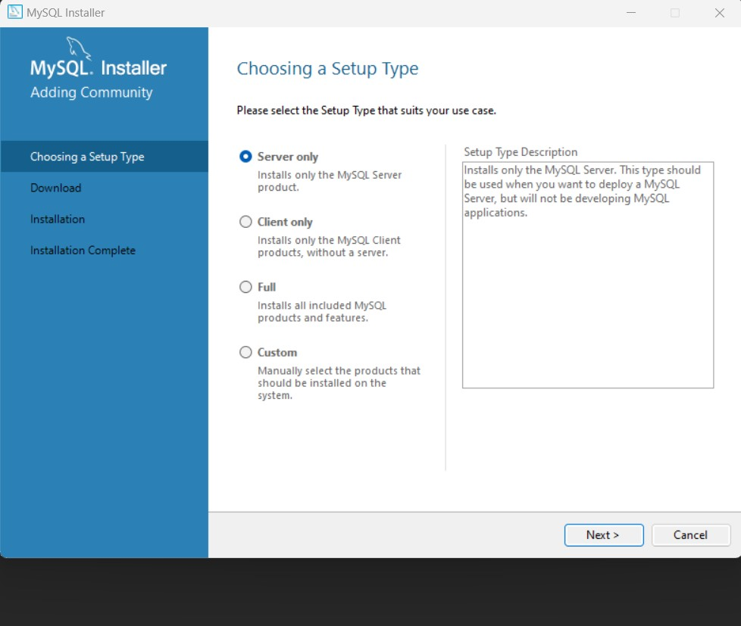

1. Click Next until the installation and finished.
2. A configuration wizard for the database will appear thereafter. Use the default settings for networking.

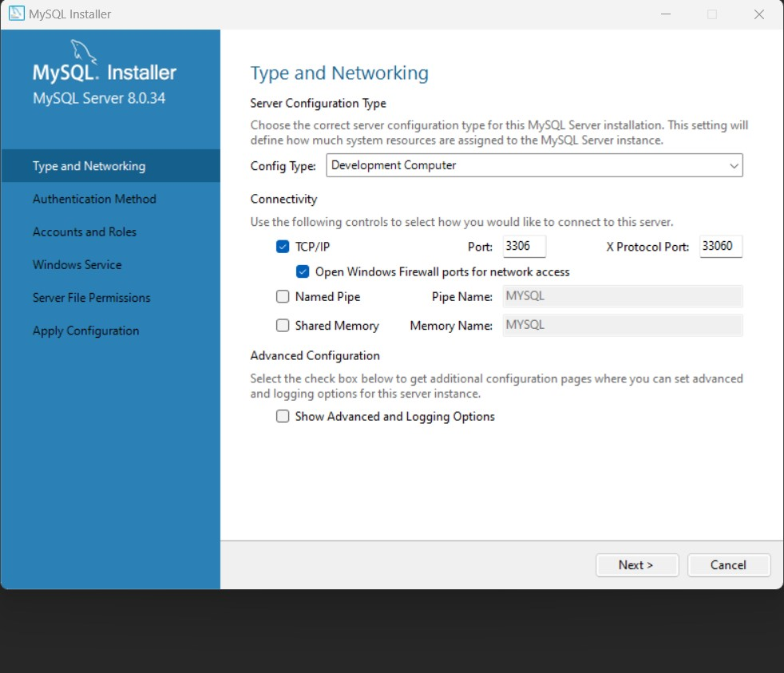

1. For account and roles, enter the below root password:
   1. Root password: Fu11St@ckCh@113ng3

1. Thereafter, click next until the configuration has completed.

## Set up MySQL Workbench and import database

1. Download and install: <https://dev.mysql.com/downloads/installer/>
2. Follow the onscreen prompts until the installation is complete.
3. Access the GitHub software repository and download the exported database which will be in the folder named Database.
4. Open MySQL workbench. Navigate to Database > Connect to Database from the menu at the top of the application.
5. Replicate the below configuration. Select the button named “Store in vault” and enter the password for the root account then select OK.

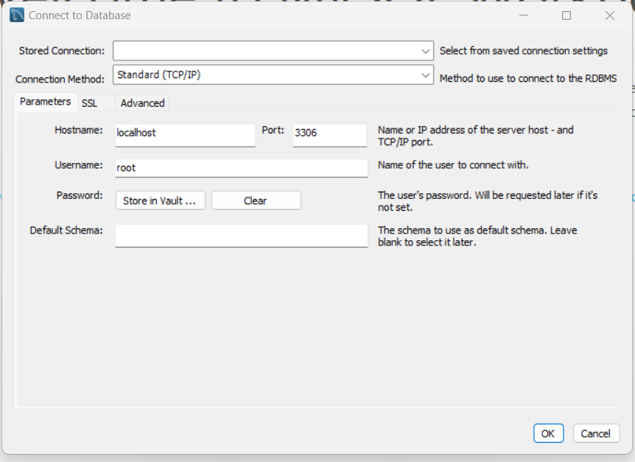

1. After adding a connection, you will see the connection added under MySQL connections. Select this connection.

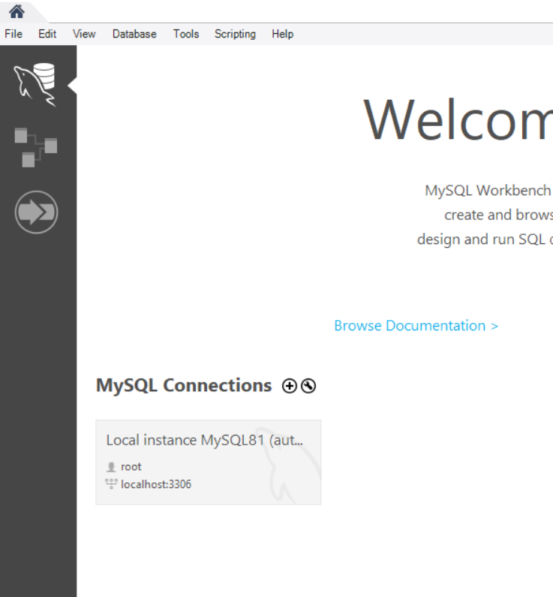

1. From the MySQL connection, select the Data Import/Restore option for the menu on the left.

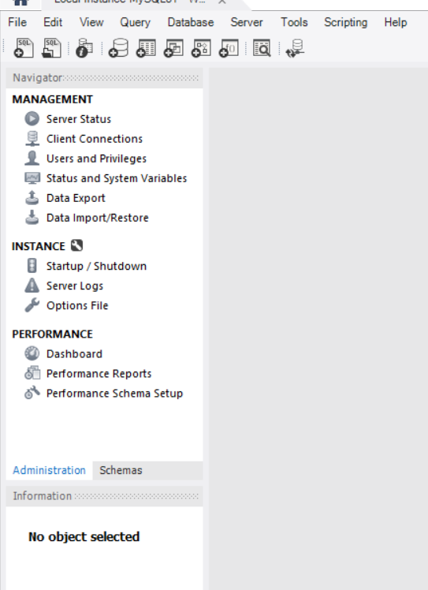

1. Select the Import from dump project option and select the folder with the downloaded Database Export from GitHub.

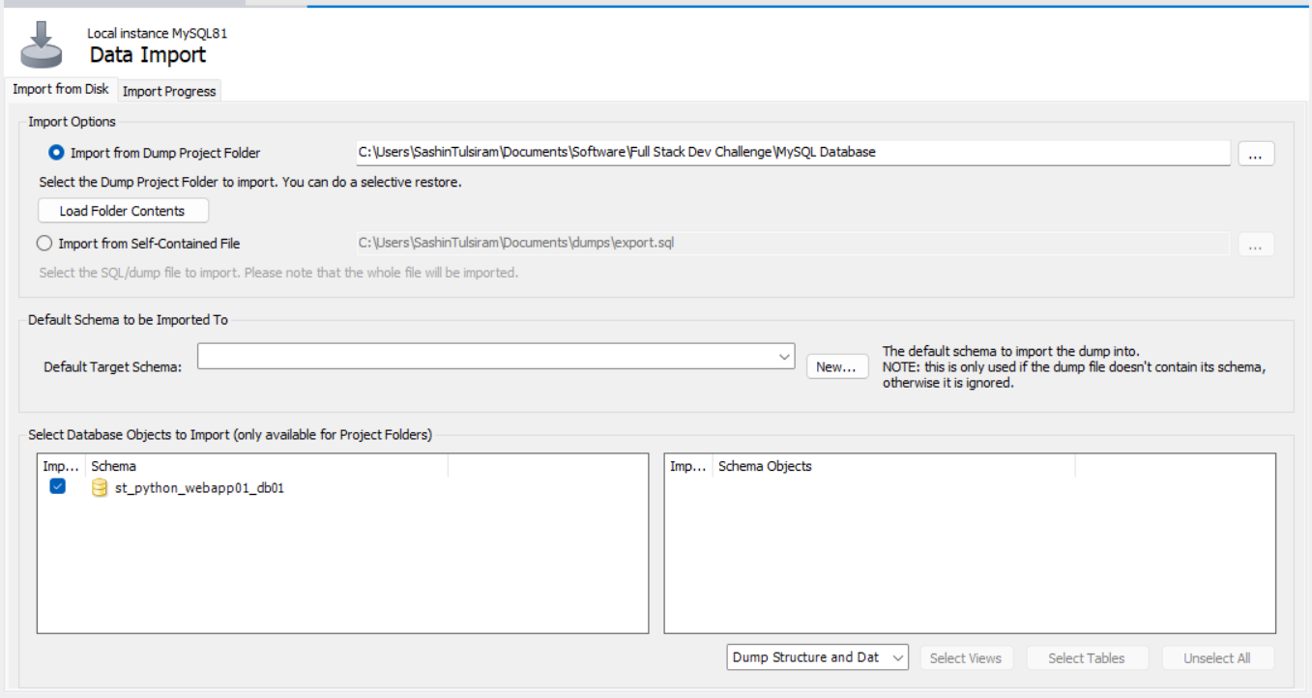

1. In the Default Schema field, click on the New button then enter in st_python_webapp01_db01 for the Default Schema name. Click on the highlighted schema as shown in the image below. This will update the schema objects table.

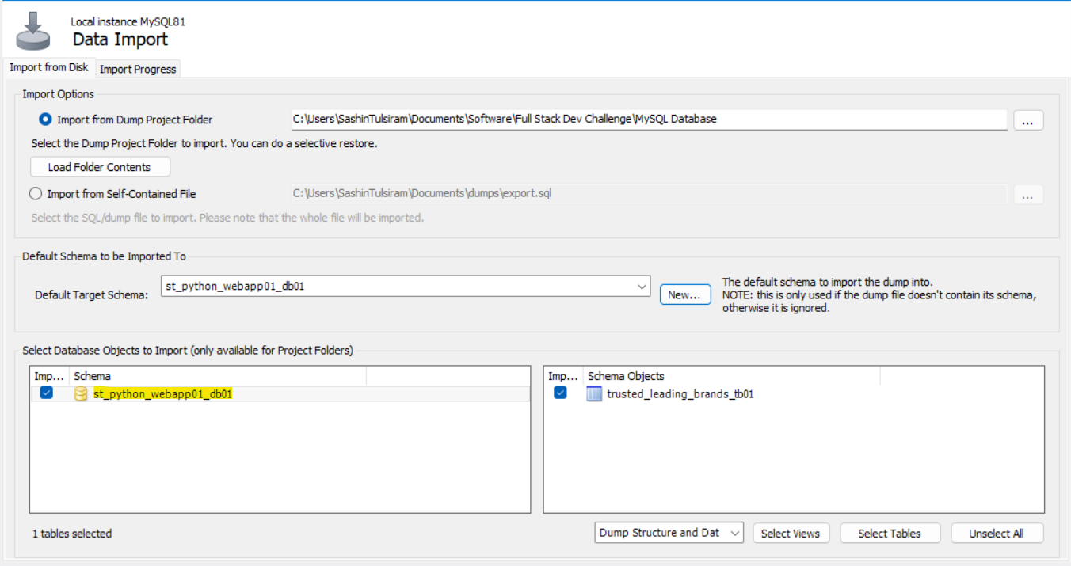

1. Next, click on the tab at the top named Import Progress and select the button to Start Import.

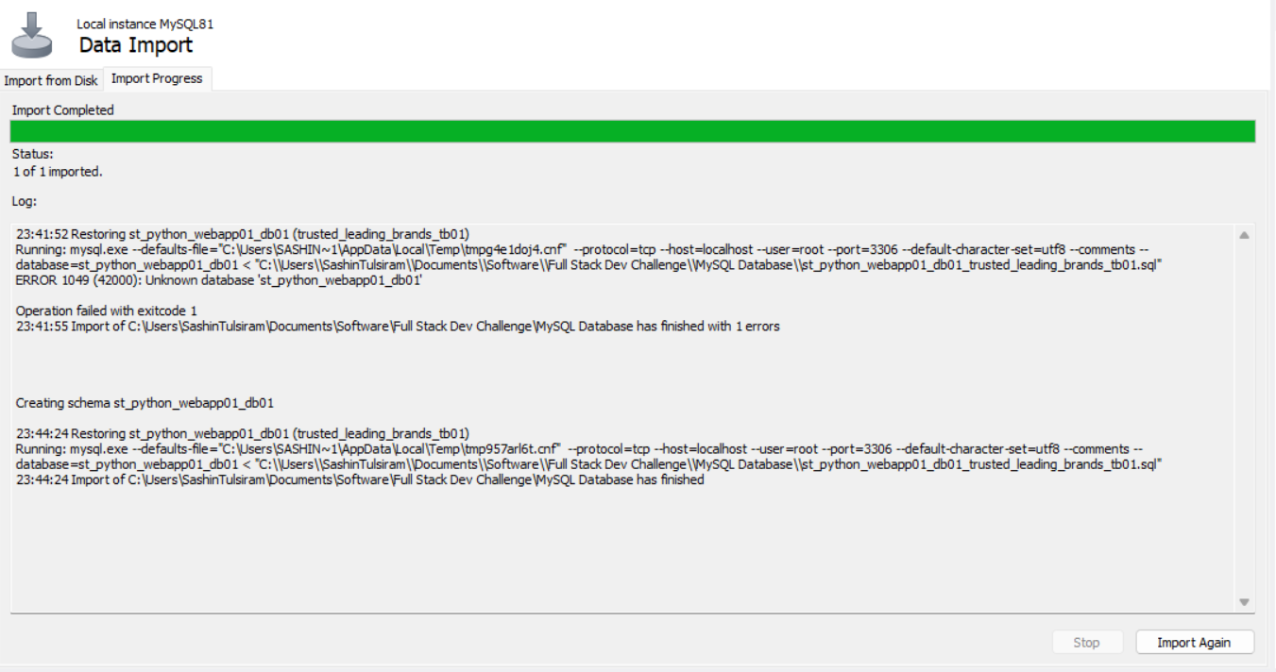

1. You will then be able to access the database from MySQL workbench and view the data stored in the database.

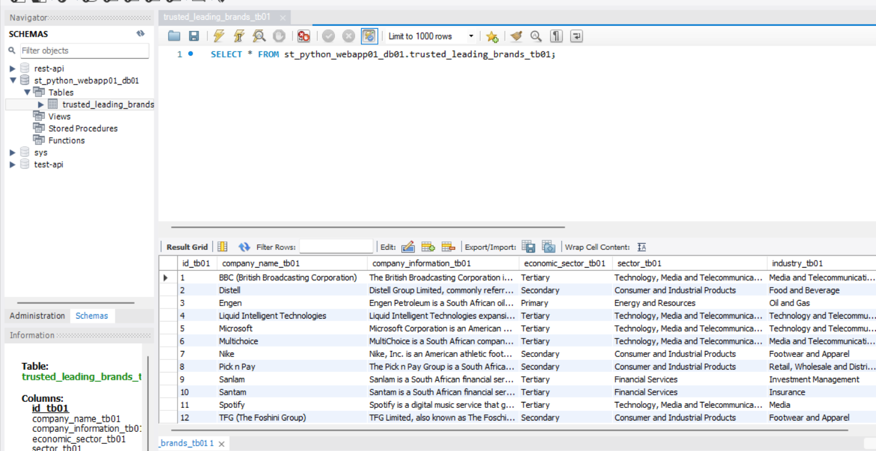

## Install NodeJS 20.5.1

1. Download and install NodeJS: <https://nodejs.org/en/download/current>

## Install Python 3.11.x

1. Download and install Python: <https://www.python.org/downloads/>

## Clone the GitHub repository

1. https://github.com/sashintulsiram/Python-Web-App-1.0.git

## Create a virtual environment

1. From CMD, open the directory for the cloned GitHub repository and run the command: cd webapp

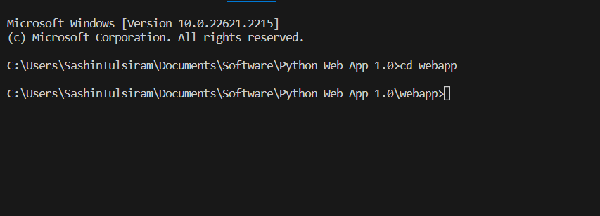

1. Run the command: python -m venv venv



1. Run the command: venv\Scripts\activate

1. Run the command: pip install -r requirements.txt

1. Run the command: deactivate

# Test Web Application

## Start Web Application

1. Start Python backend –
   1. From CMD, open the directory for the cloned GitHub repository and run the command: cd webapp
   2. Run the command to start virtual environment: venv\Scripts\activate
   3. Run the command to start Python backend with REST API: python main.py

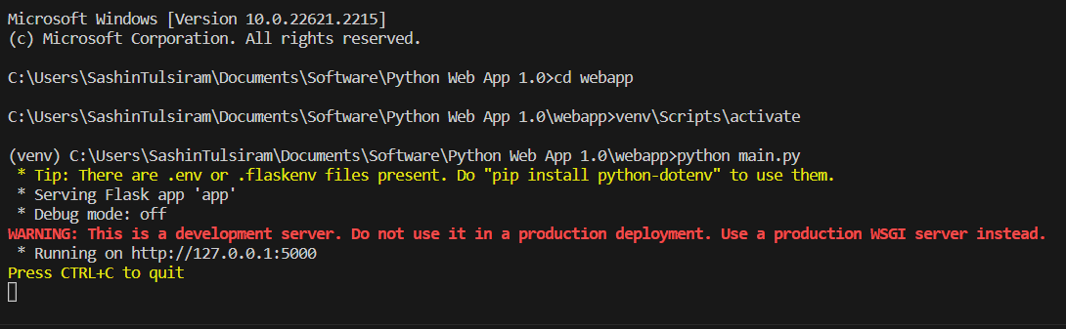

1. Start React frontend –
   1. Open a new CMD terminal window, open the directory for the cloned GitHub repository and run the command: cd react-app
   2. Run the command to start React frontend: npm start

## Illustration of Web Application

# Contact Information

Please contact me on any of the below channels if you require assistance in setting up your web application.

* Email: sashintulsiram@gmail.com
* Phone: 074 939 6705
* WhatsApp: 074 939 6705